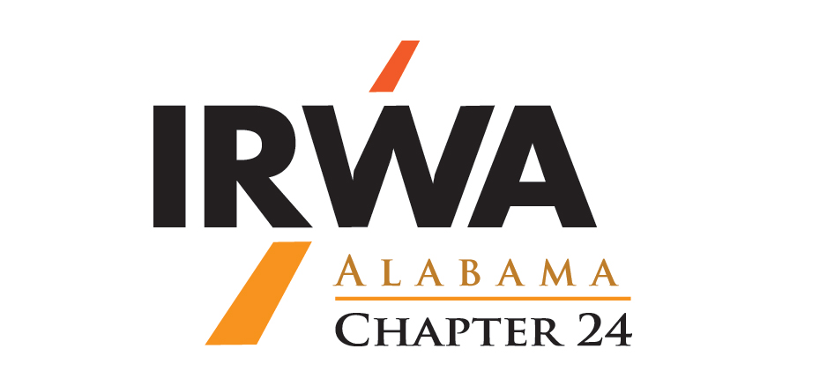
61st Annual Chapter 24 Right-of-Way Conference
March 4-6, 2020
Embassy Suites by Hilton
2410 University Blvd
Tuscaloosa, AL 35401
205-561-2500

REGISTRATION FORM

NAME ______________________________________________________________________________
COMPANY ______________________________________________________________________________
ADDRESS __________________________________________________ PHONE _____________________
EMAIL ______________________________________________________________________________

Wednesday March 4th
Course 403-Easement Valuation (register online @ www.irwaonline.org)
8:00 a.m. – 5:00 p.m.

Chapter 24 Board Meeting
5:00 p.m. – 6:00 p.m.

Thursday March 5th
Chapter 24 Winter Conference
8:00 a.m. – 5:00 p.m.

Ribfest Social
Dreamland BBQ
100 Bridge Avenue
Northport, AL 35746
6:00 p.m. – 8:00 p.m.

Friday March 6th
Chapter 24 Winter Conference
9:00 a.m. – 12:00 p.m.

TOTAL REGISTRATION FEE is $150.00 per person and includes the Ribfest Social.
(Course 403 not include in the $150.00 registration fee. Please register online @ www.irwaonline.org)

Make payment payable to IRWA Alabama Chapter 24 and remit to:

Jason Drummond
Alabama Power
600 North 18th Street, Bin 12N-0982
Birmingham, AL 35203
205-257-4204 office
205-257-1220 fax
jsdrummo@southernco.com

Even if you plan to pay upon arrival, please fax or email your registration form.
HOTEL DEADLINE FOR BLOCK RATE IS February 3rd - Group Code: RWA

The Hotel Web Page Address is:
https://embassysuites.hilton.com/en/es/groups/personalized/T/TCLRTES-RWA-20200304/index.jhtml?WT.mc_id=POG

