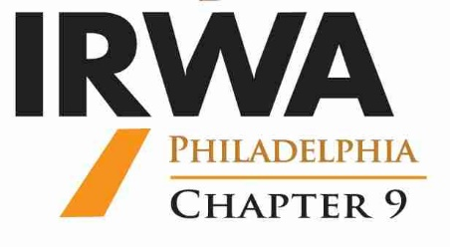

**International Right of Way Association**

**Spring Forum - Region 4**

**April 21 and 22, 2022 – Lahaska, PA 18931**

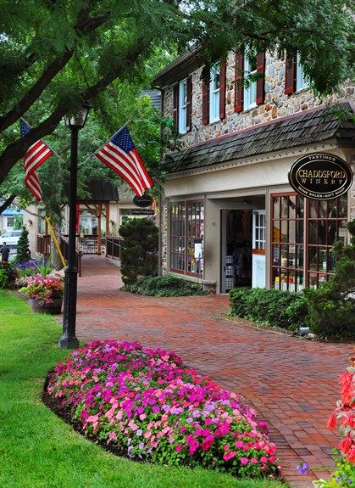

D

**Date: February 25th**

**Dear IRWA Members and Interested Parties,**

**The Members and Executive Board of the Chapter 9, Philadelphia respectfully invite you, your family, friends and coworkers to attend the Region 4 Spring Forum scheduled for Thursday April 21st and Friday April 22nd, 2022 in Lahaska, PA at Peddlers Village. Peddlers Village offers a charming shopping area with excellent restaurants and a quaint bed and breakfast Inn called the Golden Plough, where a block of rooms will be reserved for our guests. We will follow all safety guidelines and have handicapped accommodations available.**

**The theme this year is “Rebuilding America’s Infrastructure” and we will have an impressive assortment of industry speakers not limited to Federal, State and private entities with interesting educational updates.**

**If you are able to attend, please fill out the following registration form and send payment to: Maria White 24 Garren Lane Mountain Top, PA 18707-1131. The early bird prices will end on March 1st, 2022. If, for any reason, the event gets cancelled you will receive a full refund.**

**Please note, if your entity has any swag-type giveaways you can bring to put into the registration bags or for raffle gifts, please let us know. It is not an obligation, but just a request. We will be filling the registration bags the evening before the event.**

**INTERNATIONAL RIGHT OF WAY ASSOCIATION**

**REGION 4 SPRING FORUM**

**HOSTED BY CHAPTER 9 PHILADELPHIA**

**APRIL 21 AND 22, 2022**

**Name:_____________________________________________________________**

**Member#:__________ Chapter:____ SR/WA:_________ Certification:________**

**Company/Agency:___________________________________________________**

**Address:___________________________________________________________**

**Telephone:______________________ Email:____________________________**

**Guest Name(s):_____________________________________________________**

**Any Special Requests:________________________________________________**

**------------------------------------------------------------------------------------------------------------**

**Registration Fees**

**Thursday, April 21st (One Day Registration) – Day 1**

**Type Qty Fee Fee Amount Early Bird (After 3/1/2022)**

**(Before 3/1/2022)**

**Member _______ $50.00 $60.00 $_________**

**Non-Member_______ $65.00 $75.00 $_________**

**\*Guests _______ $25.00 $25.00 $_________**

**One Day Registration Includes, Breaks, Lunch & Evening Networking Hospitality Event**

**Friday, April 22nd (Second Day Registration) – Day 2**

**Type Qty Fee Fee Amount Early Bird (After 3/1/2022)**

**(Before 3/1/2022)**

**Member _______ $150.00 $170.00 $_________**

**Non-Member_______ $165.00 $185.00 $_________**

**\*Guests _______ $100.00 $100.00 $_________**

**One Day Registration Includes, Breaks, Lunch & Evening Networking Hospitality Event**

**Thursday, April 21st & Friday, April 22nd - 2 Day Combination**

**Type Qty Fee Fee Amount Early Bird (After 3/1/2022)**

**(Before 3/1/2022)**

**Member _______ $185.00 $200.00 $_________**

**Non-Member_______ $215.00 $230.00 $_________**

**\*Guests _______ $125.00 $125.00 $_________**

**\*No Registration Fee for guests – cost covers meals only**

**Total Due: $_________**

**___________________________________________________________________**

**Make Checks Payable to “IRWA Chapter 9” and email form to** [**mawhite@pa1call.org**](mailto:mawhite@pa1call.org)

**Mail all Registrations to: Maria White**

**24 Garren Lane**

**Mountain Top, PA 18707-1131**

**Hotel Reservations: Golden Plough Inn - Peddlers Village**

**2517 Street Road New Hope, PA 18938**

**Reservations (215) 794-4004**

**IRWA Rate: $119 + tax 20th and 21st**

**$169 + tax 22nd**

[**www.goldenploughinn.com**](http://www.goldenploughinn.com)

**Forum Location: Cock-n-Bull 215-794-4010**

**53 Peddlers Village**

**Lahaska, PA 18931**

**Corner of Upper York Rd and Street Road**

**Lat/Long (40.34818 -75.03289)**

**Any Questions: Maria White** [**mawhite@pa1call.org**](mailto:mawhite@pa1call.org)

**570-954-3545**